UNIVERSITY OF AZAD JAMMU & KASHMIR
Department of Software Engineering

Graphic Designing Lab Report (Mid Term Exam)
Name: Saqlain Mushtaq
Roll No: CET_27
Course: Graphic Designing
Semester: 4th Semester
Instructor: Engr. Ahmed Khawaja
Date: 30-04-2026

Introduction
This report explains the design tasks completed during the Graphic Designing Lab Exam. The purpose of these tasks was to apply the principles and elements of graphic design using Canva. All designs were created originally by using proper layout, color combinations, alignment, and visual hierarchy.

Task 1: Promotional Poster Design (Design Sprint 2026)

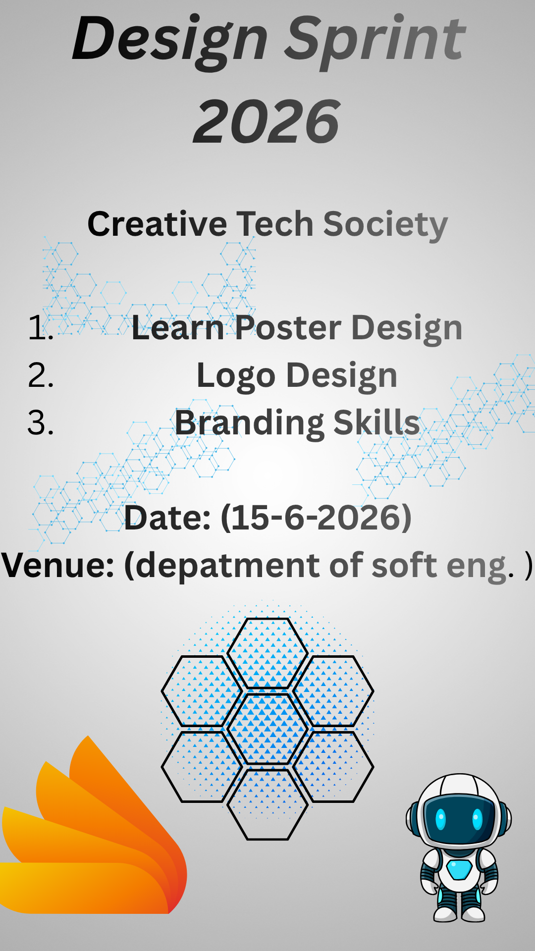
In this task, I designed a promotional poster for an event titled “Design Sprint 2026” organized by the Creative Tech Society.
First, I created a custom-sized poster in Canva. I selected a suitable background using soft gradient colors to make the design visually appealing. Then, I added the main title “Design Sprint 2026” at the top of the poster using a bold and clear font to grab attention.
After that, I included the name of the society, “Creative Tech Society,” and added event details such as learning topics including poster design, logo design, and branding skills. I also included date and venue placeholders.
To enhance the visual appeal, I used relevant icons related to design and technology. I carefully arranged all elements by maintaining proper alignment, spacing, and balance.
The final poster follows the principles of contrast, hierarchy, and readability, making it effective for promotion.

Task 2: Logo Design (Creative Tech Society)
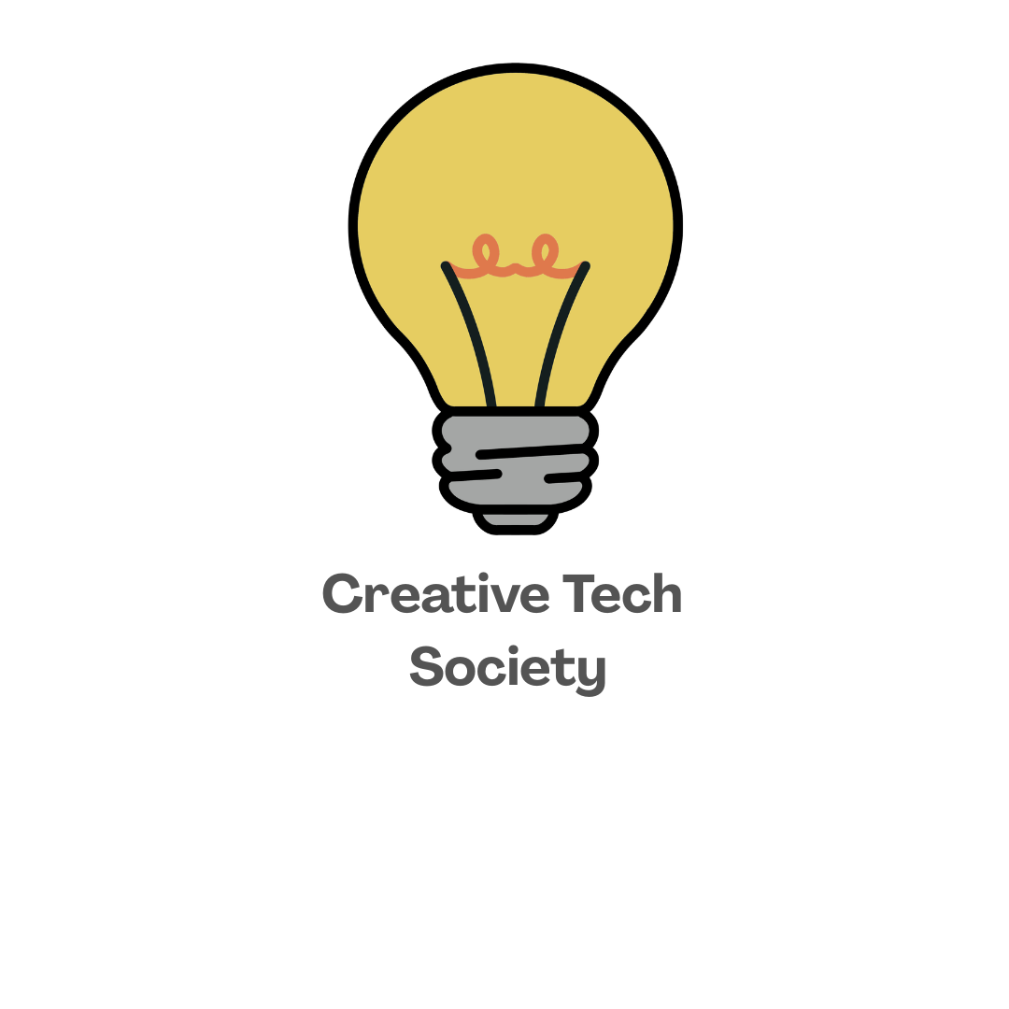

In this task, I created a simple and meaningful logo for “Creative Tech Society.”
I started by selecting a square canvas suitable for logo design. Then, I chose a light bulb icon to represent creativity and ideas, which is strongly connected to innovation and technology.
Below the icon, I added the text “Creative Tech Society” using a clean and modern font. I ensured proper alignment by placing the icon at the center top and the text below it.
I used a minimal color scheme to keep the logo professional and versatile for different uses such as posters, certificates, and social media.
The final logo is simple, clear, and meaningful, effectively representing creativity and technological innovation.

Task 3: Campaign Poster (Save Energy, Save Future)

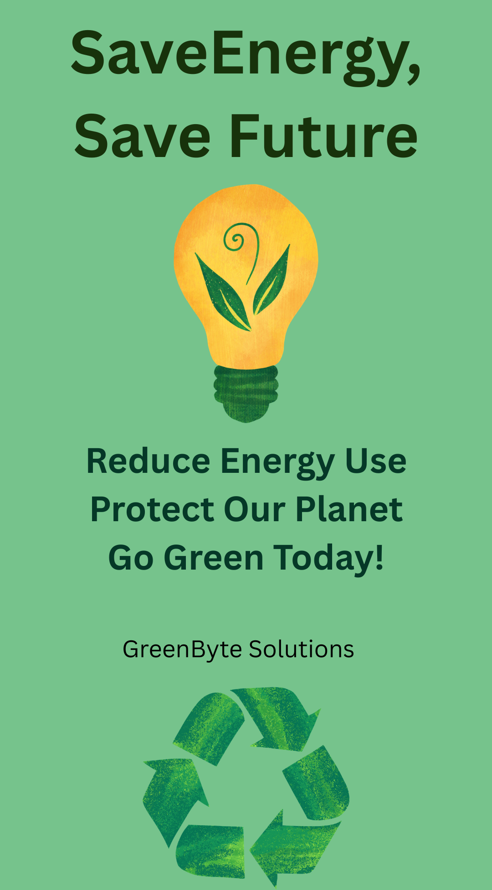
In this task, I designed a campaign poster for “GreenByte Solutions” with the message “Save Energy, Save Future.”
I began by selecting a green-themed background to represent environmental awareness and sustainability. I added the main title at the top of the poster in bold font to clearly deliver the message.
In the center of the poster, I placed an eco-friendly icon such as a bulb or earth symbol to visually represent energy conservation. Below the icon, I included a short and clear message encouraging people to reduce energy usage and protect the planet.
At the bottom of the poster, I added the company name “GreenByte Solutions” to give it a professional identity.
I used a consistent green color scheme, proper spacing, and alignment to ensure readability and visual balance. The design effectively communicates the campaign message in a simple and attractive way.

Conclusion
All tasks were completed using Canva by applying the basic principles of graphic design such as balance, contrast, alignment, simplicity, and readability. Each design was created originally without using ready-made templates. The final outputs are visually clear, well-structured, and suitable for their intended purpose.

